## This feature supports saving connections to CRM instances for reuse

To access the saved connections click ‘Saved XRM Connections in the settings dropdown. The saved connections display in a grid as per the screenshot below

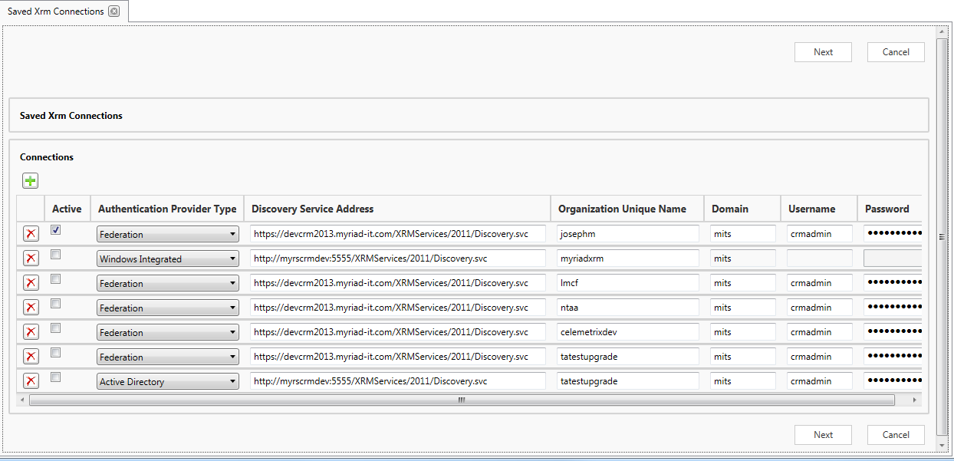

* To add a new Connection click the  icon above the grid
* To remove a connection click the  icon beside the connection to delete
* To activate a saved connection check it tickbox in the Active column and click the Next button

Adding a new Connection is essentially the same as the standard ‘Connect To CRM’ though it will not be saved until you click next to add it to the subgrid and then click next when viewing the subgrid to save the connections

It also has the Active checkbox and will only be activated as the current connection if that Active checkbox is ticked

* Enter the authentication provider type*, details for the crm instance* and credentials of the crm user

*if the crm instance is ifd specify federation

*how to access the discovery service address and organization unique name is shown in a subsequent screenshot

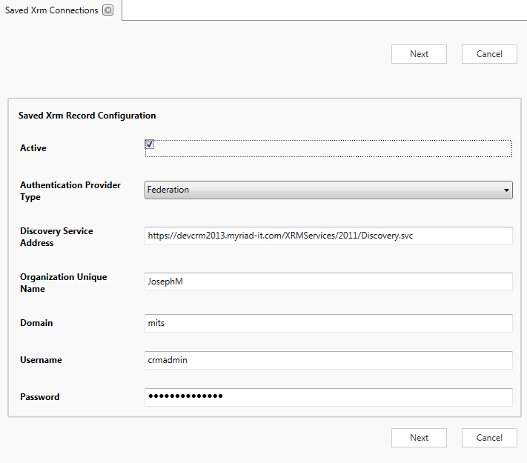

The discovery service address and organization unique name are accessible in crm by navigating to settings -> customizations -> developer resources

